**Hedging With Options**

**Hassan Fayyaz**

**Underlying exposure:** Suppose XYZ corporation has underlying exposures of long Euro 10 million (receivable) to be received in December, so the corporation bought a 6-month Euro put option to protect the investment from large downside moves.

**Spot Price:** 1.2118/euros

**Strike Price:** 1.21545

**6 months forward:** 1.21545/euros

**MTM value:** $12,154,500

**Premium:** $178,000

To find the premium, we multiply 10 million in revenue by the last price $0.0178/euros.

**Table**

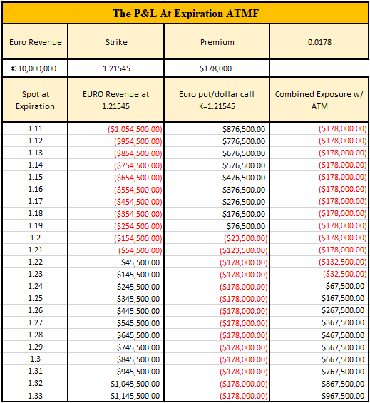

**Graph**

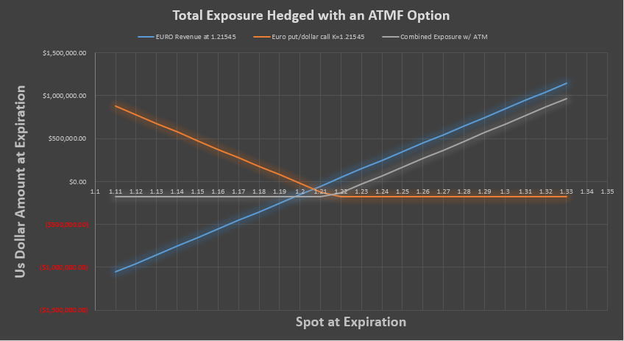

**Explanation**

In this scenario, the volatility of Euro/USD for one year is 6% and the spot rate is to be estimated volatile between 1.12 and 1.31.

1. **Not Hedging:**

The purpose of hedging contracts is to lock future prices and secure a commitment to deliver products regardless of price fluctuations in the future. These contracts also reduce uncertainty and stress for the investor because nobody knows what the future holds, as unexpected things like COVID can result in a market crash. Therefore, some possible risks associated with not hedging are profit loss due to price fluctuations caused by inflation, foreign exchange currency, and many other reasons. But with a bigger risk comes bigger reward and by not hedging one unlocks the chances of making the most profit possible, and another benefit of not hedging is that you will never have to pay a premium. Therefore, not hedging has its advantages and disadvantages.

In this particular case, if the corporation decides not to hedge than the possible gain in profit with an EUR/USD increase of 1.31 would be $945,500 and the possible loss from the trade at 1.12 would be $954,500.

1. **Hedging with a forward:**

Hedging with a forward will lock a future price for the corporation to protect themselves from potential losses due to price fluctuations. To hedge with a future, the hedger signs a contract and is obligated to stick with it. Producers and consumers hedge forward when they believe that prices will rise or fall, and it might affect their business negatively. When hedging with a forward, buyers worry about falling prices (because they want to buy cheap stuff), and sellers worry about rising prices (because they want to sell their product/services at a higher prices). They both want to mitigate this risk of losing money, so they hedge.

In this case, if the price rises then the buyer would benefit since the product/services are bought at a cheaper price, and the seller, in this case, would regret it as the possibility of earning extra profit was lost and vice versa. Therefore, hedging with a forward is a safe bet, as it might lead to higher profits, and at the same time, there is a chance that the hedger might lose the chance to earn extra profit. Regardless of everything, hedging with a forward also has its benefits; if you hedge with a forward then there is no need to buy a premium as we do for hedging with options.

1. **Hedging with an Option:**

Hedging with an option is another financial instrument that is a derivative. These derivatives allow to buy or sell without making it an obligation. In this case, to secure an opportunity to buy or sell, the hedger buys a premium. If the price product/service being bought settles above the strike at expiration, then the call seller keeps the premium and is obligated to sell the product/service to the buyer. The buyer, in this case, earns profit regardless of him paying the premium because he bought a product/service at a cheaper price and earned profit by selling it at a higher price. And if the product/service does not settle above the strike at expiration then the call seller keeps a premium and the call buyer losses money.

**Conclusion:**

In conclusion, I would say not hedging, hedging with options, and hedging with a forward all have their pros and cons. Therefore, one will never know what option might benefit them in the future, but I believe it is always better to hedge than not to hedge regardless of the hedging method being used.